Format-Menu

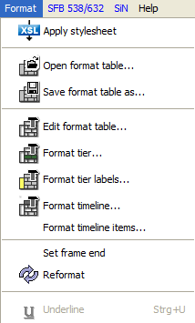

With the format menu the font type, font size, text and background colors etc. can be changed. The format options change both the way the musical score is displayed on the screen, as well as the way the output is displayed. (Print, RTF-, HTML- or SVG document). Font size and bold print should not be used as carriers of linguistic information. In EXMARaLDA these are exclusively coded with the used symbols or symbol chains. (see also "Segmentation-Menu"). Formatting is thus not an integral component of the actual transcription but is treated like additional information that is only relevant for the presentation in the editor and the output. Furthermore it is saved as a separate file and not in the actual transcription.

The system architecture ensures that only whole tiers or all tier labels or all time axis labels can be formatted. It is not possible to format individual sections of a tier, e.g. underlining single words in the transcription, print them in bold or change their font. .

The reason for this is that this kind of formatting can only be transformed into other file formats with some limitations. It is not possible, for example, to import underlinings or bold print into a data base If you would solely like to use these features for display purposes, you can later apply the desired changes to an exported RTF document. If they are part of your transcription conventions, however, (e.g. emphasized speech needs to be underlined according to your conventions) you should consider whether you can express the marked phenomena with the help of symbolic means.

The default format is automatically applied to every transcription made with the editor (to configure the default font see "Edit > Edit Preferences…“). Editing the format of a tier (or of the speaker labels or the time axis) is done by calling the following dialog via Format > Edit format table:

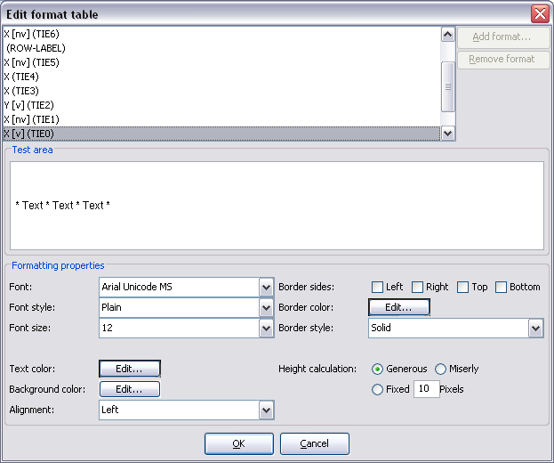

Font: sets the font.
Font style: sets the font type ("Plain", "Bold“ or „Italic“).
Font size: sets the font size (in points) .

Example:

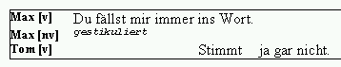 | Labels: "Times New Roman, Bold, 10 pt“  Tier 1 and 3: "Times New Roman, Plain, 12 pt“  Tier 2: "Courier New“, Italic, 8 Pt“

Text color: sets the color of the text.
Background color: sets the background color of the text.

Choosing the color is done by selecting it from the dialog.

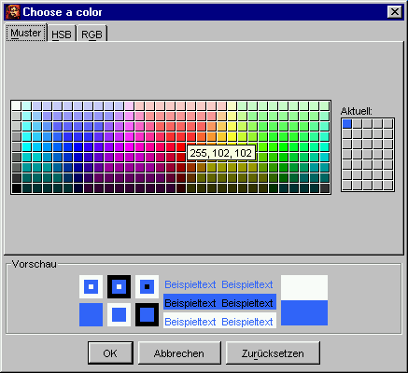

Examples:

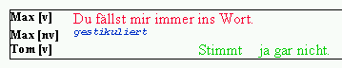 | Tier 1 to 3: Red, blue and green as text colors
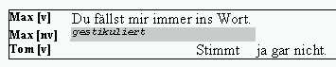 | Tier 2: gray as a background color  (to emphasize the expansion of non-verbal events for example)

Alignment: sets the alignment of the text within the event description. This setting only takes effect in the editor. For the output the font is always aligned to the left.

Example:

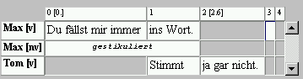 | Tier 2: "Center"

Border sides: defines whether the events should be framed.
Border color: sets the frame color.
Border style: defines the style of the border ("solid“, "dashed“ or "dotted“).

Examples:

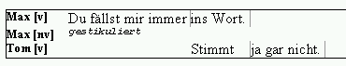 | Tier 1 and 3: gray solid border lines on the right
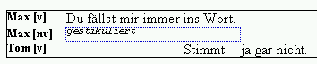 | Tier 2: blue dotted border lines on the left, right, above and below  (to emphasize the expansion of non-verbal events for example)

Height calculation: defines by which method the tier height should be calculated. There are three alternatives:
Generous: This is the default setting. The tier height is adjusted to the biggest symbol of the chosen font as a guideline, much like in text processing.
Miserly: If this option is chosen the tier height is adjusted to the biggest symbol actually used in the tier in question.
Fixed: Is this option is chosen, the tier hat can be set by the user. The unit are Pixels (is equivalent to the font unit "points“).

Format > Apply stylesheet
Generates a new formatting for the current transcription from a stylesheet (see also Appendix D). The stylesheet that is specified in the user settings (see Edit > Preferences...“) in "Transcription to format table“ will be used. If there us no entry, a local stylesheet will be used.

Format > Open format table...
Opens a saved format table and applies it to the currently opened transcription.

Format > Save format table as...
Saves the current format table as a separate file with a new name.

Format > Edit format table...
Opens a dialog for editing numerous tier formats.

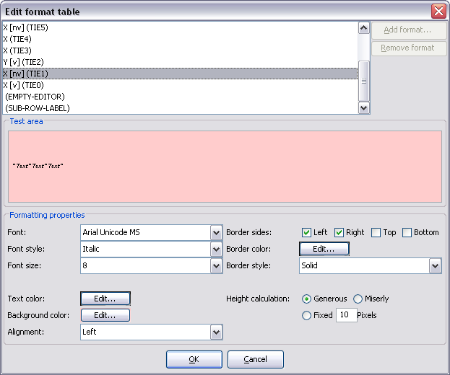

Choose the format from the list that you would like to edit and choose your required settings in the lower half of the dialog.. You can enter sample text in the field "Test Area“ . Close the dialog by clicking OK to apply changes.

Format > Format tier...
(Shortcut: CTRL + F on Windows, ⌘ + F on Mac)

Opens a dialog to format the currently selected tier.

Format > Format tier labels...
Opens a dialog that allows formatting of the speaker label:

Format > Format timeline...
Opens a dialog that allows formatting the time axis:

Format > Format timeline items...
Opens a dialog to set the format of the time points on the time axis. The settings will be displayed in the editor as well as used the RTF or HTML output or when printing.

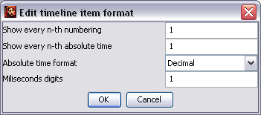

Show every n-th numbering: every n-th numbering in the time axis will be shown. Enter 0 to have no numbering shown at all.
Show every n-th absolute time: every n-th absolute time value on the time axis is shown. Enter 0 to have no absolute time values shown at all.
Absolute time format: defines whether the absolute time values are to be shown "Decimal“, hence in seconds, or as ("Time“) in the format hh:mm:ss.xxx. 183.21 ("Decimal“) and 03:03.21 ("Time“) represent the same, namely "3 minutes, 1 seconds and 230 milliseconds“.
Milliseconds digits: defines how many post decimal positions should be used when displaying milliseconds..

Examples:

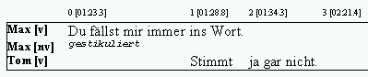 | Show every n-th numbering: 1  Show every n-th absolute time: 1  Absolute time format: Time  Milliseconds Digits: 1
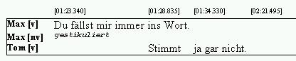 | Show every n-th numbering: 0  Show every n-th absolute time: 1  Absolute time format: Time  Milliseconds Digits: 3
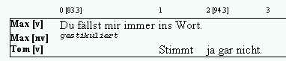 | Show every n-th numbering: 1  Show every n-th absolute time: 2  Absolute time format: Decimal  Milliseconds Digits: 1

Format > Set frame end
Specifies the position of the frame of the musical score. The default setting is set in such a way that all tiers lie within the musical score frame. If you would like to change this, reorder all the tiers so that the tiers you would like to placed into the frame are on top. (for this see also "Tier > Change tier order“). Select the last tier that is supposed to be below the frame by clicking the tier label. Only choose the menu item hereafter.

(The position of the musical score frame can easily be seen by the tier labels on the screen : The tier labels outside of the musical score has a different frame.)

Examples:

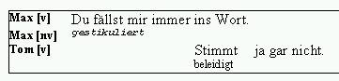 | no “frame end“
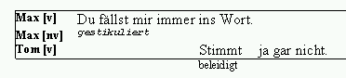 | “frame end“ placed after the third tier

Format > Reformat
Forces a recalculation of the musical score format. This can be of use when you've manually adjusted some intervals on the time axis for example.

Format > Underline
Underlines the currently selected text. This underlining is not considered formatting in the conventional sense. They way it is executed depends on the settings found under "Edit > Preferences > Font > Underline Method".

If "Underline in a separate tier with category XXX" is selected the event in question is split and the entry is placed into an annotation in a associated tier. This complies with the recommended procedure for marking accents of the HIAT manual (Rehbein et al. 2004)

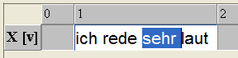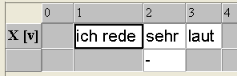

The settings "Underline in the same tier (using a diacritic)" on the other hand, insert suitable diacritics into the currently selected tier that form an underlining.

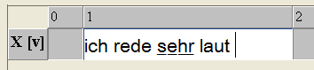

The latter method is more comfortable normally, but limits the systematic search-ability of the transcription.

